‘The Boxer’ plugin Instructions

- Installation

Download the .ccx file and double click. That should open the ‘plugin manager panel’ and install the new plugin. (This panel can be accessed via the Plugins Menu in photoshop and you can uninstall the plugin from this panel at any time if you so wish.)

Once installed, the plugin controls are accessed from the ‘Plugins’ menu, which will launch a ‘Panel’ that can be moved, closed and docked as per all normal panels in Photoshop.
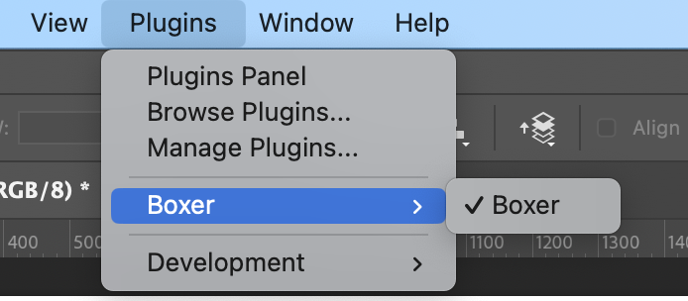

(Sometimes on first installation the panels show up empty – just clicking between the two tabs will populate this).

- Usage

There are two primary features :
- Colour Transects – which copies an image and creates a ‘palette’ or ‘swatch’ alongside that copy and includes sampled colours from the image.
- Grids – that will create a regular layout of frames to which you can add images, that can subsequently be easily manipulated.

Controls for both features appear in separate tabs in the same photoshop ‘Panel’. There are also options dialogs accessed via the ‘hamburger’ menu icon at top right of the panel.

- Colour Transects

There are two basic steps to create a transect. The first is to create the base transect, and the second is to ‘optimise it’ for aesthetic purposes. This second step can be repeated as many times as you like, even after closing and re-opening the .psd file.

3.1 Creating a transect

You will need to open the image which you want to create the transect for. Make all of your adjustments before you start, including cropping if you want a custom aspect ratio. A larger file will work best.

Important : The plugin will base the transect on the ‘top-most’ active layer of the active document, so if nothing happens make sure you select a layer and try again. You may need to merge layers before creating the transect.

Open the plugin panel, and select the ‘Transects’ tab. You can create a document using the defaults, or last used settings simply by clicking on the ‘Create a Transect’ button, but you can control the process using the settings on this panel.

    - Settings

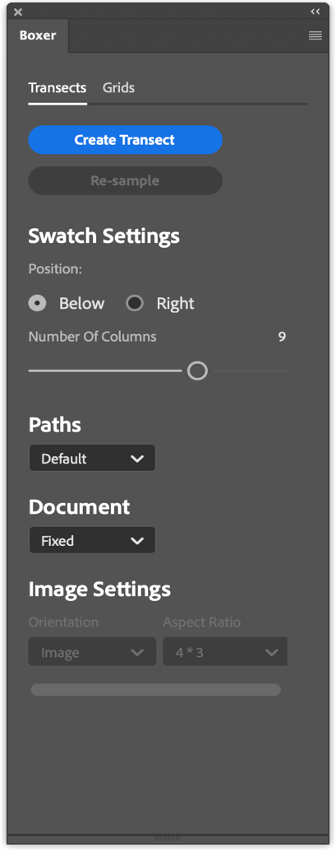
- The Position can be either Below or to the Right, and will determine where the swatch is drawn relative to the image. “Below’ will result in a portait-ish document format, and “Right” will give more of a landscape document.

- In this version, the number of ‘rows’ in the swatch area is fixed to 3, whilst the number of ‘columns’ is controlled by the slider. With the ‘Right’ style, these are transposed so you will get 3 columns.

- The ‘Paths’ option allows you to choose where the ‘starting’ paths are drawn – the points along the paths are where the colours are sampled. There are options for ‘Horizonal’ and ‘Vertical’, and the ‘Default’ creates two diagonal lines and a horizontal. You will be moving these points later, so there is no right or wrong choice.

The ‘Document’ options are ‘Fixed’ and ‘Free’ .
With the Fixed option :
- The transect document will be sized according to the values in the ‘Transect Options’ dialog (see below), including the margins.
- The ‘swatch position’ is used to determine the paper layout – Portrait or Horiziontal for ‘Below’ or ‘Right’ respectively.
- The image will be positioned centrally in the ‘frame’ and will be sized to fit.

With the ‘Free’ option, the “Image settings” options will be enabled:
- The ‘Orientation’ determines the shape of the frame into which the image will be placed.
  - ‘Image’ - the frame will retain the aspect ratio of the source image.
  - ‘Portrait/Landscape/Square’ should be fairly self-explanatory.
  - With Portrait/Landscape you can pick an option for the aspect ratio.
- The output document will be sized to fit the frame, plus the swatch, plus the margins. (It uses the default doc with as a starting point). This does mean you could end up with a file that does not easily fit onto standard aper sizes for printing – if this is important then use the ‘Fixed’ option.

3.1.2 Transect Options

Transect options are set in the dialog launched from the menu in the panel.

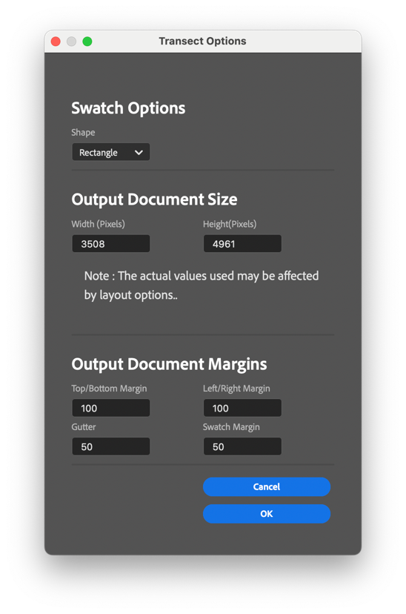

- The swatch items can be Square or Circle
- You can select the output document size (default values are for an A3 print). These MAY be overridden for a given transect if using the ‘Free’ option in the main panel.
- Document margins - Top and bottom margins are the same, as are left and right margins. There will be a gutter between the main image and the swatch, and finally all margins within the swatch will be the same.

    - Created document

Press ‘Create a transect’ and the plugin will create a new document (with the name of the original document, appended with “_transect”. The document will have a few key items :
- A Photoshop ‘frame’
- The image inside the frame “Image Layer”
- An initial swatch based on the image, each box will be in it’s own layer, and these are grouped inside another layer
- 3 ‘Paths’ (which may or may not be visible initially)

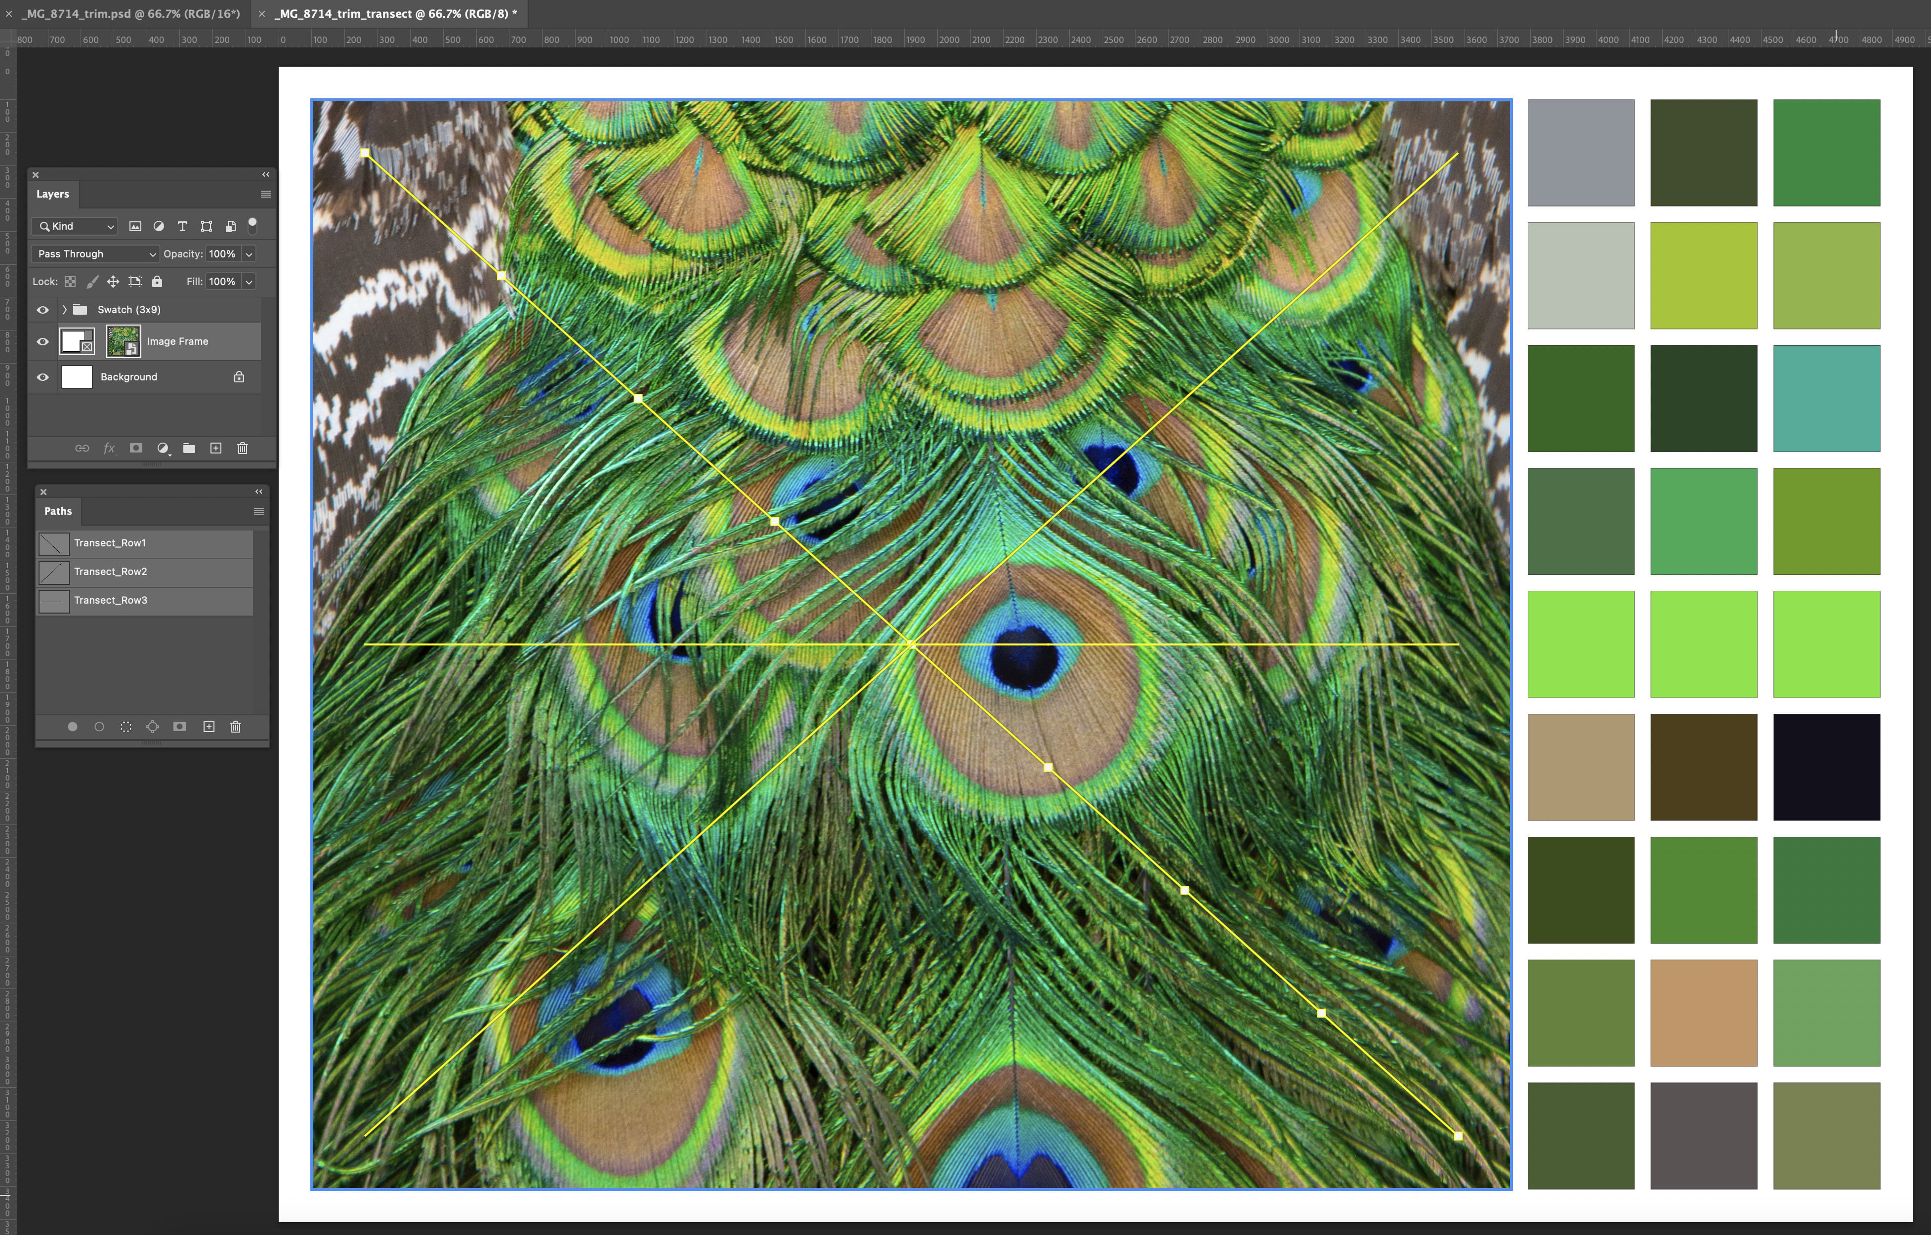

3.2 Modifying the transect

3.2.1 Image adjustment

The image can me moved around within the frame, you can zoom etc. Note that having done this you will need to ‘Re-sample’ to have the swatch reflect the colours of the newly arranged image.

3.2.2 Colour sampling/re-sampling

Now you can adjust the colours included in the swatch….

The plugin creates a set of ‘paths’, with each one corresponding to a row of swatch elements. The path has a number of points along it, each one corresponding to a ‘column’. The colour at the path point location is used to fill the swatch in the matching row/column swatch element. Note : In a ‘Right’ positioned transect rows and columns are transposed.

If you open the Paths panel (Window=>Paths) you will see the three paths, corresponding to the option chosen in the settings. Because you can move the points around there is no fundamental ‘right’ or ‘wrong’ path design – it’s just a starting point.

The paths in the ‘default’ option are set along each diagonal and across the centre horizontal. Note : The three lines all cross near the centre point of the image so if you have chosen an odd number of points, then the three swatch elements in the centre column will be identical.

Select one of the paths, and then by using the ‘Direct Selection Tool’ (an option in the Path Selection tool access using Capital ‘A’) , you can move the points on the path to a more ‘interesting’ point where you would like the colour sampled. Simply click on the point to be moved and drag it to where you would like the sample to be taken. (Note : the swatch will not update until you click on ‘Re-sample’)

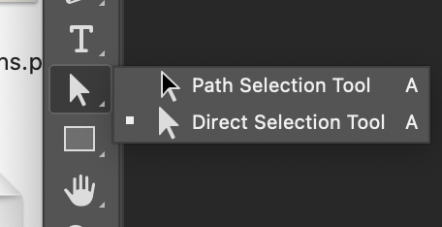

When you have moved the path point(s), you can use the ‘Re-sample’ button in the panel to update the swatch from the new point locations. You can repeat that as often as you like to get the effect you want.

In the example below, see how the path (Transect_Row1) has been moved and the first column of the swatch colours have been updated to match
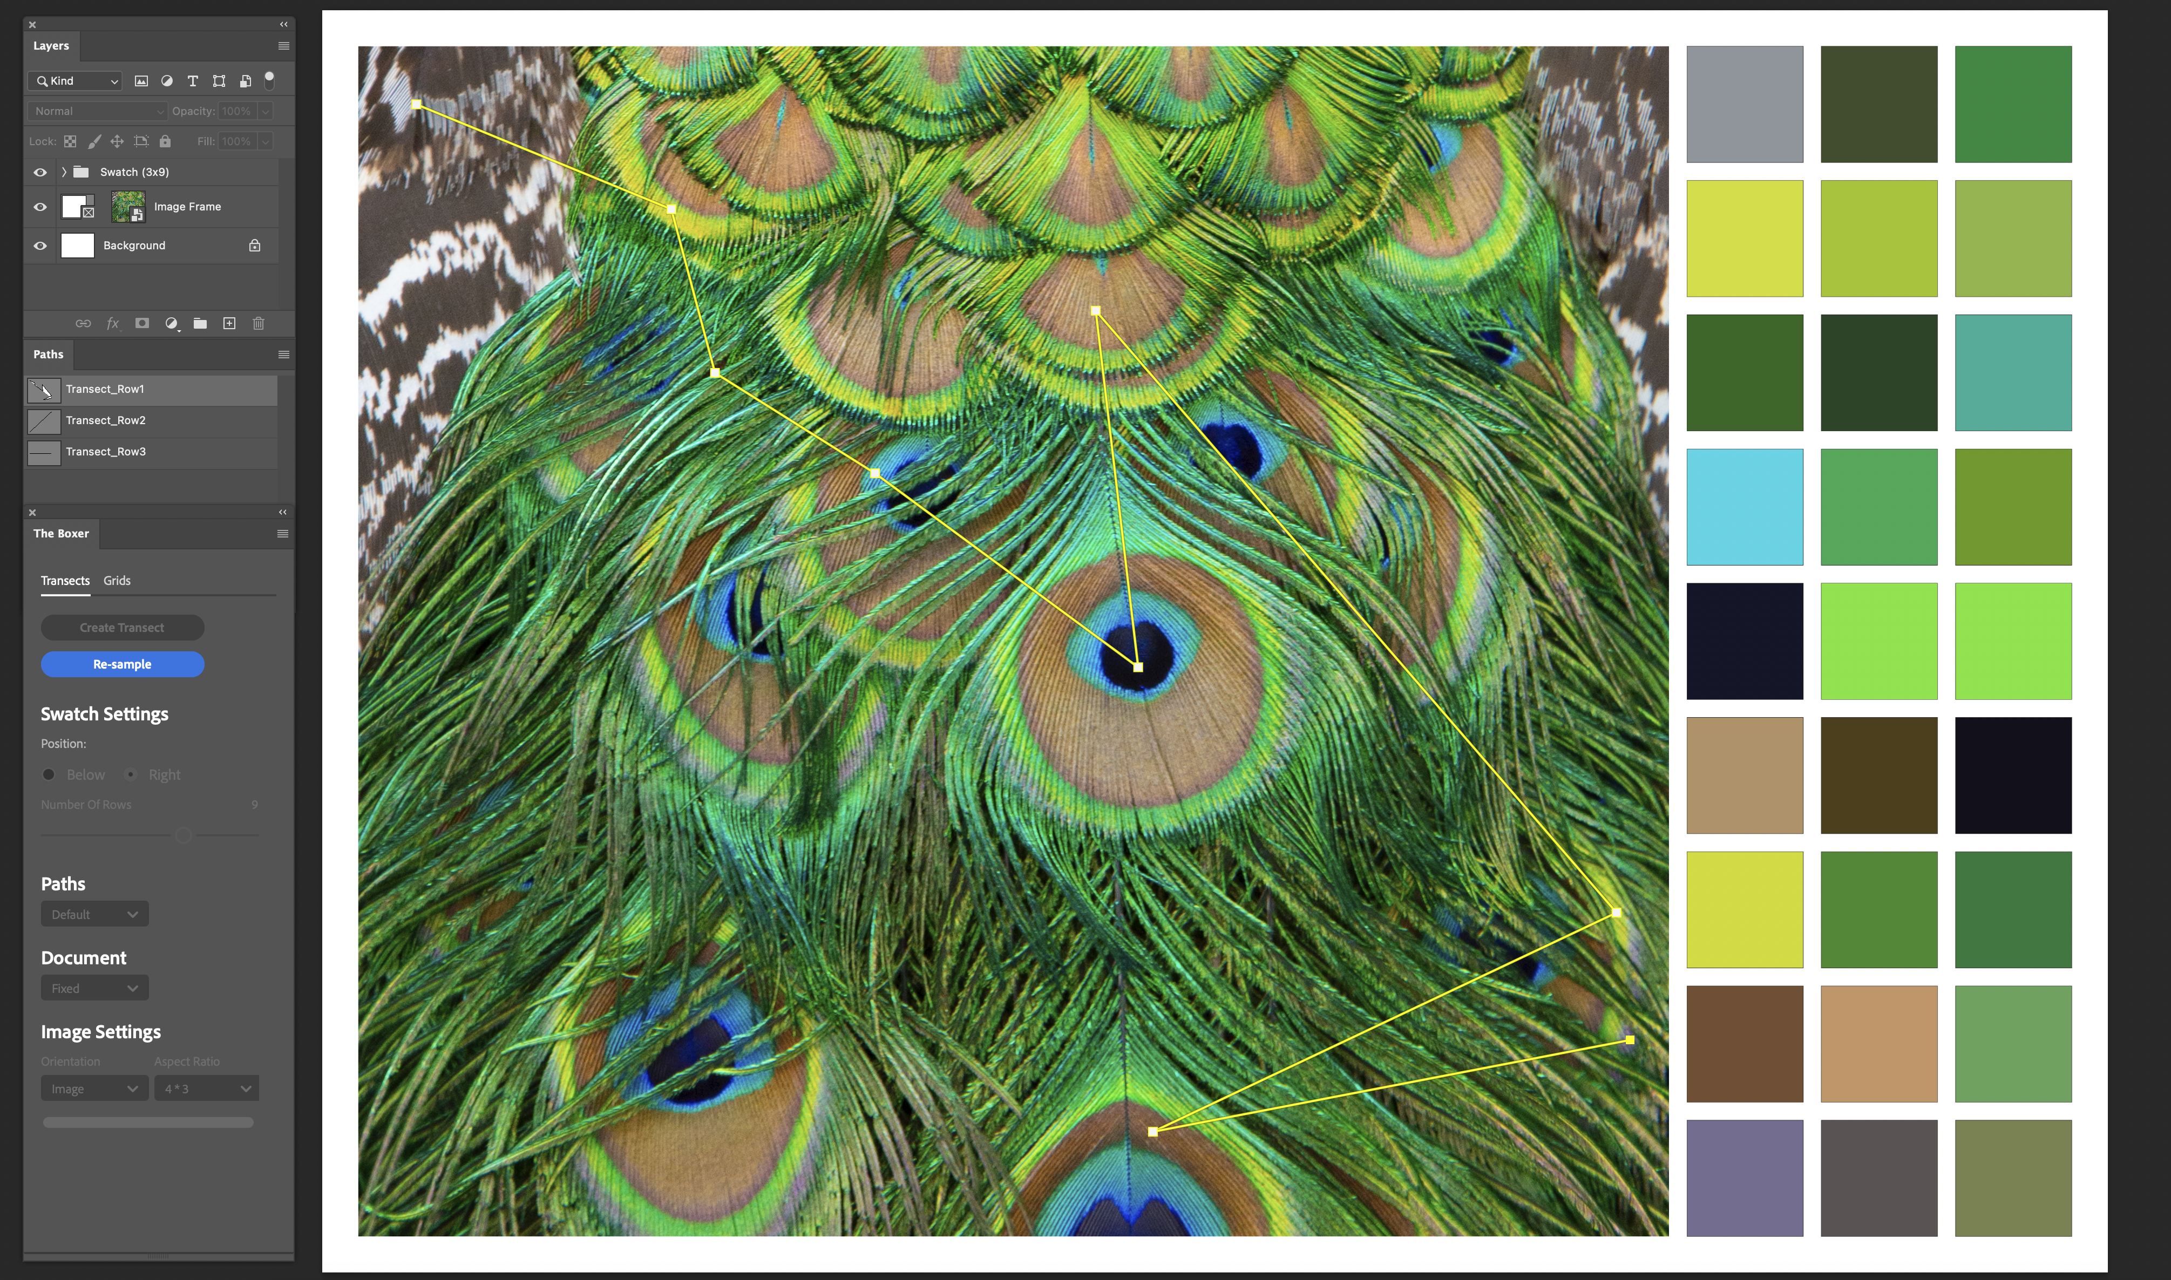

Note : Command-H ( on mac) will toggle display of the Paths to give a clearer view. You can also change the colour of the paths to make them clearer in the tool options for Paths.

WARNING - DO NOT :
Move path points outside of the Image
Rename the paths
Delete the paths or points therein
Rename the Swatch Layers
Rename the Group Layer containing the Swatch layers
Delete the Swatch Layers
Rename the Image Layer

If you do, then you won’t be able to ‘Re-sample’

You CAN do things like add an adjustment layer on top of your image, and then when you re-sample, it will pick up the adjustments. Saving the file as a .psd will allow you to return and continue to re-sample at a later date. When you re-open the file, simply make sure the panel is open and the Transect Tab is selected.

Of course once you are happy with the transect, you can flatten the image etc, but you will no longer be able to re-sample the colours.

- Grids

The basic process for a grid presentation is to
- create your target document
- create the frame layout
- add your images
- re-arrange to get the look you want.

4.1 Create a layout

You will first need to create an empty document using the ‘New’ command in photoshop. The size/orientation is your choice and will depend on the look you are going for. (In theory you can use an existing file and create the grid there, but you might end up doing more work to get the right outcome.)

Open the Wizards panel and select the ‘Grids’ tab.

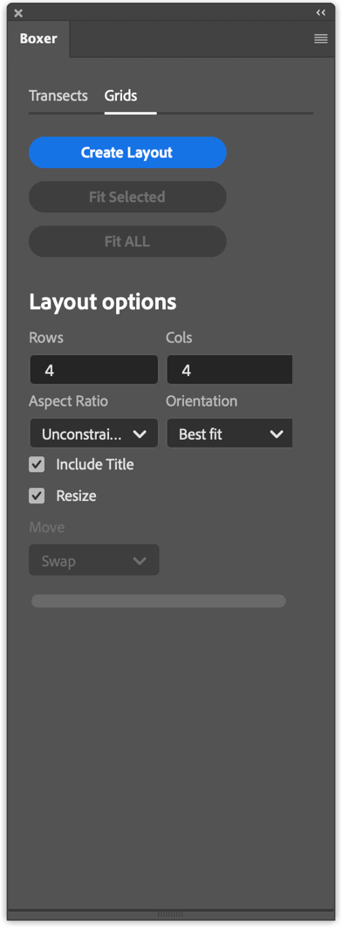
The layout will be created with a number of PS Frames organised in a grid, with the number of rows and columns defined in the panel.

By default, the plugin will try to maximise the size of each frame, whilst respecting the Margins and Gutter values you set.

If you prefer a fixed aspect ratio, then select from the drop down, and also if you want a defined orientation for the frames you can choose that as well.

Depending on your selected values, the layout created may not fit well onto the document size chosen and the outer margins may not be able to be respected. The plugin will optionally resize (shrink) the document to match the defined margins.

A Text layer for a title is optionally added.

Depending on your choices the layout will look something like this with it’s associated layers (which are labelled as Frame-<ROW>-<COL> :

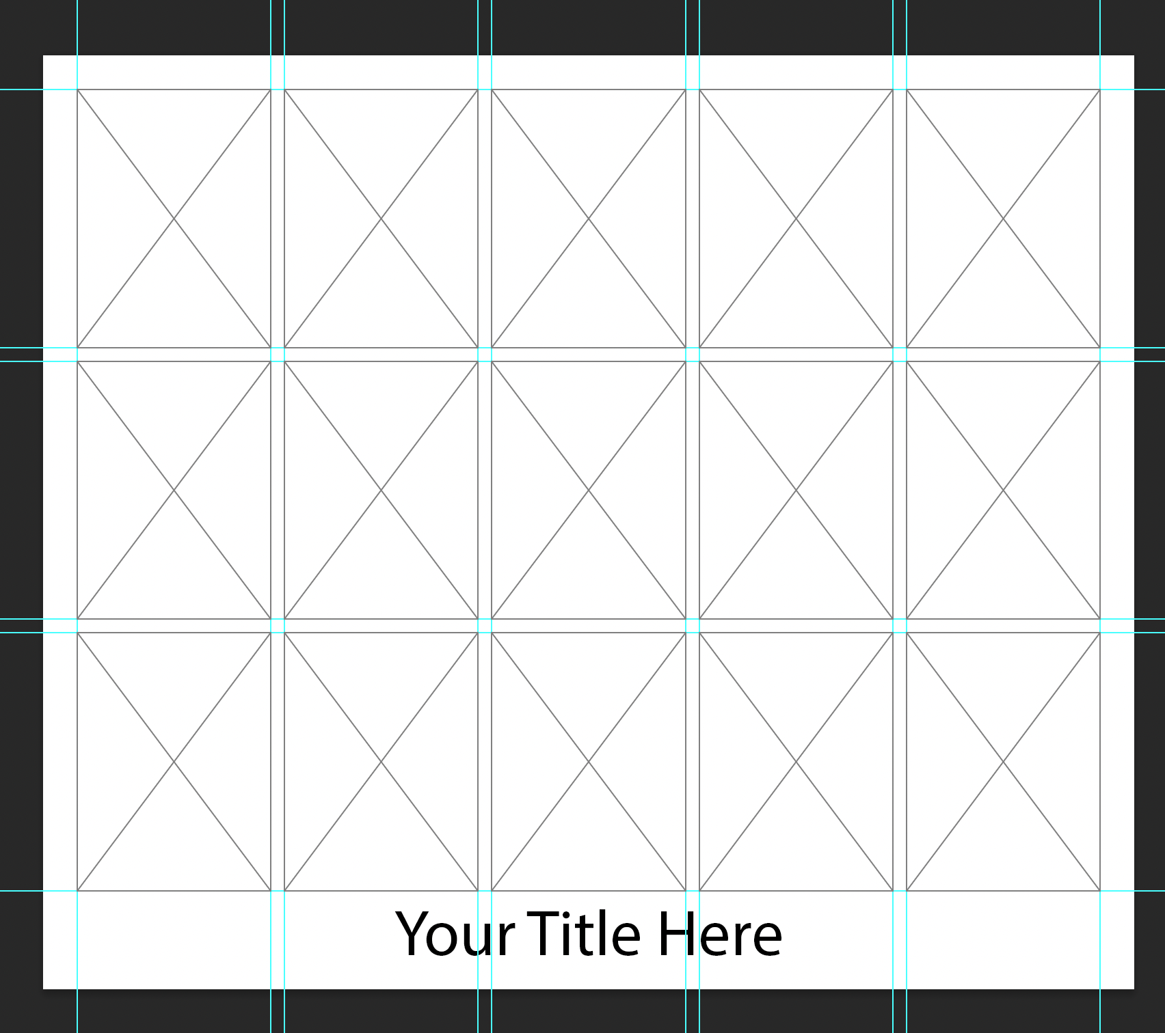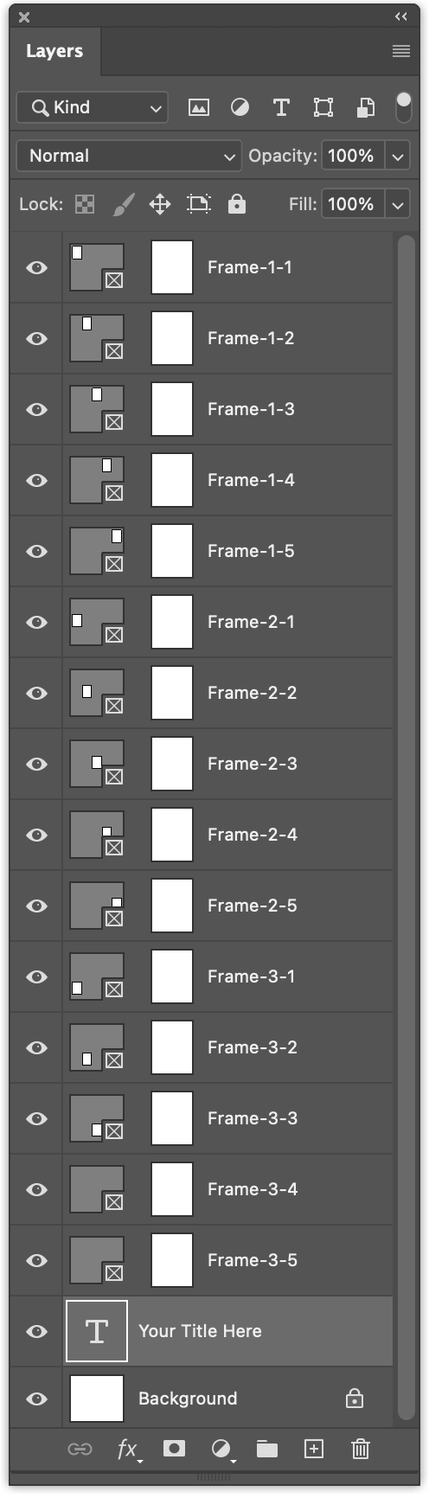

If the Layout is not quite as you wanted Ctrl-Z will undo the whole creation in one go, so you can tweak your values and try again.

4.2 Adjusting the images

At this point you can start to add your images in the normal PS manner by dragging or linking as you prefer. All normal features are available within each frame.

There are 2 buttons that will resize the layers inside the frames. This function will try to fit as much of the image into the frame given constraints of aspect ratio etc. There is an option to just fit selected images, or to fit all in one go.

Note: this function does not respect any resizing you have done yourself, so use with care. It’s probably only really useful to get a a starting point, or if your images have already been trimmed to the correct aspect ratio.

4.3 Moving images

WHILST THE PANEL IS OPEN….. If you drag a frame and it’s associated image so that it’s centre point is over one of the other frames and drop it, the plugin will rearrange the images, based on the value of the ‘Move’ picker:

“Swap” : this will directly swap the two items, but will leave other frames unaffected.. You can swap with emptry frames too. Be sure that the frame is selected, and not just the image.
“Shuffle” : This will move other images to the one by one to the vacated position, and the place the dropped item into the new location. Be aware that the shuffling will take place across rows and columns, so the last/first item in a row may be moved to the start/end of the next/previous row.
“None” : This will disable the function (same as closing the panel).

(When the panel is hidden, this function is disabled to better manage system resources)/

